CHAIRMAN/SECRETARY NEEDS TO READ THIS OUT!
Derbyshire YFC Weekly Update!

The carcase judging will be on Wednesday 23rd October at Redferns abattoir, Harpur Hill, Buxton SK17 9HT, junior and intermediate at 6.30pm and senior at 8.00pm. The live pig stock judging will be held later in the year. The same competitor must judge both live and carcase. The points from these competitions will go forward to the Rally points.

If clubs would like to propose a motion at the County AGM it must be received in County Office by Thursday 24th October. The County AGM is on Thursday 21st November at County Hall, Matlock

Ashbourne YFC have a charity Halloween Doo on Friday 25th October at the Royal Oak, Mayfield, DE6 2BN

Farmers Harvest Festival at the Agricultural Business Centre, Bakewell on Sunday 27th October at 2.30pm. Details attached

Future Dates!
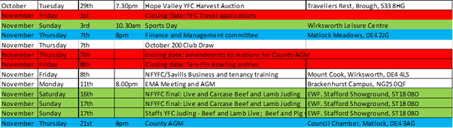

Jane Smith
County Administrator
Derbyshire Federation of Young Farmers’ Clubs
www.derbyshireyfc.org.uk
www.nfyfc.org.uk

Office Hours:
Monday and Thursday 10.30 am – 4.00 pm
Friday 2.00 pm – 4.00 pm
Thursday evening 8.00pm – 10.00 pm

