CHAIRMAN/SECRETARY NEEDS TO READ THIS OUT!
Derbyshire YFC Weekly Update!

Members who were successful in the recent live and carcase judging need to confirm if they are able to go forward to the next round at the English Winter Fair on Saturday 16th and Sunday 17th November asap:
Live and Carcase (live on Saturday, carcase on Sunday) beef – Charlie Rhodes, James Hodgkinson, Molly Astley and Sam Woolley. Lamb – Vicky Beal, Jack Charlton, James Bunting and Jamie Fotherby
Staffs YFC competitions (Sunday only) Live lamb – Ruby Astley and Charlotte Atkinson, Live Beef – Cheyenne Wright and Tom Etches, Beef Carcase – Tom Wildgoose and Sam Etches and Pork Carcase – Martha Bland and Rachel Hadfield

Hope Valley YFC have their Harvest Auction on Tuesday 29th October at the Travellers Rest, Brough starting at 7.30pm. Everyone Welcome! Donations would be very much appreciated.

Club reports for the yearbook are required by Thursday 31st October, see attached. Also page sponsorship is needed

Any members who are thinking of applying for a YFC travel trip in 2020, please note the closing date for applications is Friday 1st November. Choose from 14 locations with options on staying with host families, volunteering and team travel.

Sports Day is on Sunday 3rd November and entries have been received: Kwik Cricket – Barlow/Pleasley, Ashover, Ashbourne and Belper. Netball – Pleasley, Ashover, Belper, Ashbourne and Derby. Football – Pleasley, Ashover, Belper, Ashbourne and Derby. Are any other clubs planning to enter?

An update from the NFYFC Council meeting, the Radnor YFC proposal of reinstating the AGM was defeated. National are trying to encourage clubs to gain 5 new members to help bring down the cost of the national levy, there is a table on the NFYFC website in the council section with a table saying how it will help the national levy decrease if we can aim for this number.

The draft agenda for the County AGM is attached if any club would like to put forward an amendment to any of the motions it must be received in county office by Thursday 7th November. Can those members who are proposing a vice president forward a few words about that person so it can be included on the agenda.

The booking deadline for YFC Ski 2020 is just under 3 weeks away. Have you booked your space yet? Get on it and book before 17th November

Future Dates!
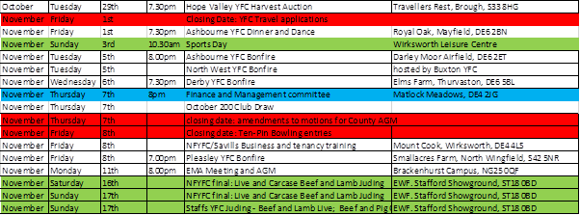

Jane Smith
County Administrator
Derbyshire Federation of Young Farmers’ Clubs
www.derbyshireyfc.org.uk
www.nfyfc.org.uk

Office Hours:
Monday and Thursday 10.30 am – 4.00 pm
Friday 2.00 pm – 4.00 pm
Thursday evening 8.00pm – 10.00 pm

