CHAIRMAN/SECRETARY NEED TO READ THIS OUT!
Derbyshire YFC Weekly Update!
Club Bonfires:
Tuesday 6th November - Barlow YFC, 7.30pm, Lydgate, Holmesfield, S18 7WB; Ashbourne YFC, 8.00pm, Darley Moor Airfield, DE6 2ET and Ashover YFC, 7.00pm, Lant Lane, Tansley, DE4 5FW
Wednesday 7th November - Belper YFC, 8.00pm, New Buildings Farm, Shottle, DE56 2BY; Derby YFC, 7.30pm, Elms Farm, Thurvaston, DE6 5BL and North West YFC, 7.30pm, Youlgrave Road, Over Haddon, DE45 1JD
Live and Carcase Judging @ English Winter Fair - Members who qualified for the Live and Carcase Judging: Beef Derbyshire A – Andrew G-C and James Hodgkinson, Derbyshire B – Sam Woolley and Molly Astley. Pig Derbyshire A – Ruth Rastrick and Matthew Clark, Derbyshire B – John Armitage and Sam Blagg. The live judging will take place on Saturday 17th and the carcase on Sunday 18th November. Members who qualified for the Staffs YFC competitions on Sunday 18th November – Live Lamb (A) Suzie Cooper and Sam Botham, (B) Matthew Burnhope and Robert Webster. Live Beef (A) Tom Weston and Jessica Langton, (B) Lucy Hollingworth and George Walker. Lamb Carcase (A) Rosie Deakin and Martha Bland, (B) Vicky Beal and Jake Williams. Pork Carcase (A) Alice Morley and Ben Wildgoose, (B) Philip Lawton and Isobelle Rodgers. Please check all these members are able to compete and let Jane know asap. Details are in the County Competitions Rule Book or contact county office for a copy of the rules to be sent.
Ten Pin Bowling competition – on Sunday 25th November at the Genesis Centre, Alfreton DE55 7DQ at 7.00pm. Closing date for entries Friday 9th November, an entry form and copy of the rules is attached.
County Tops – We are having some more county tops (rugby and polo shirts, hoodies and body warmers)printed they will be navy with white writing ‘peak of perfection’ on the reverse, YFC logo on one breast, your name on the other. An order form is attached and all orders are required by 30th November
County AGM on Thursday 22nd November at County Hall, Matlock DE4 3AG. A copy of the agenda is attached will you please ensure all last year’s award winners return the trophies: Junior Achievement – Callum Neville, Ashover and Kirsten Bradbury, Ashbourne; Club Efficiency and Membership – Hope Valley; Competitions – Buxton; Presidents Award – Ben Bakel. In addition to their Executive committee representatives each club can send 10 further representatives, please forward them a copy of the attached agenda.
Projector – The county projector is for sale at £50, initially to clubs but if there is no uptake it will be advertised on ebay. The lens requires some attention.
Finance and Management Committee meeting minutes attached
Sports Day Results Rounders – 1st Pleasley, 2nd Hope Valley. Mixed Netball - 1st Derby, 2nd Buxton, 3rd= Bakewell and Pleasley, 5th Hope Valley, 6th Ashover, 7th Ashbourne. The East Midlands round of the sports competition is on Saturday 30th March at Southwell Minster School. The teams representing Derbyshire: Rounders – Pleasley and Hope Valley, Mixed Touch Rugby – Buxton and Mixed Netball – Derby and Buxton
Derby YFC Snow Ball
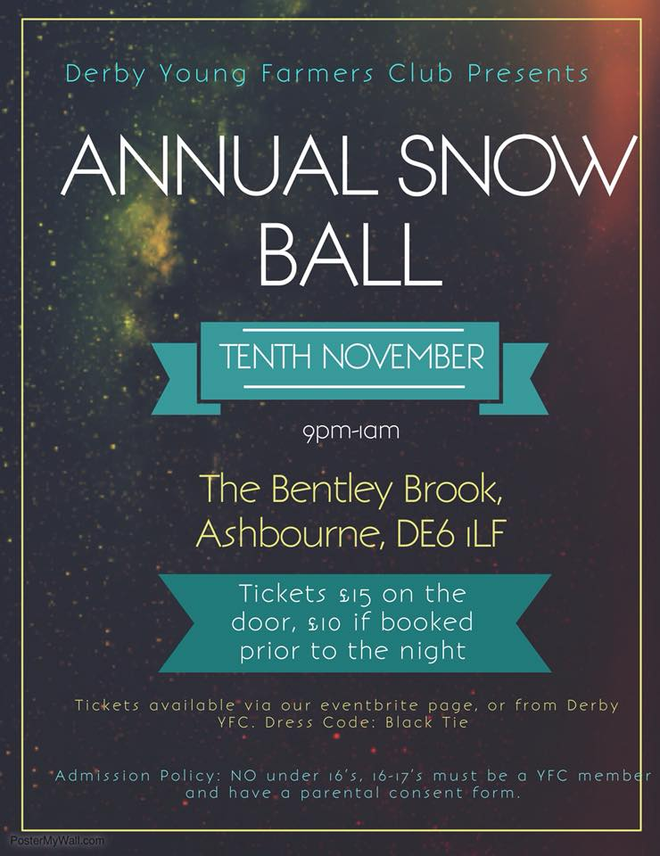
Other Organisations
Farm Business Inovation Show on Wednesday 7th & Thursday 8th November at the NEC, Birmingham. The event for farmers, landowners, rural businesses, entrepreneurs, estate, and country house owners to find the inspiration, resources and advice they need to diversify, innovate and make more from their land. Whether you want to gear up for glamping, look into alternative crops or livestock, run events on your land or revitalise rural retail, you'll find an amazing selection of ideas and inspiration at this incredible exhibition and conference. Website Link - www.farmbusinessshow.co.uk
Club Meeting Idea - I'm Becky, the Operations Manager at SellMyLivestock and Graindex. I'm just introducing ourselves and discussing us coming to give a talk at one of your meetings. We aren't here to tell you how to farm, we leave that to you, but we are here to offer you alternative trading options for farm businesses. We'd love to come and speak at one of your meetings and tell you what we're up to, what we plan to do in the future, and get some ideas and feedback from you about the website www.sellmylivestock.co.uk www.graindex.com
YFC Forthcoming Dates !
Farmers Weekly Ag Careers Live is a free event held on the Thursday 15th November from 10:00 – 15:00 at Villa Park, Birmingham
County AGM – will take place on Thursday 22nd November in the Council Chamber, County Hall, Matlock starting at 8pm.
Ten Pin Bowling competition on Sunday 25th November
Field Officers meeting Thursday 29th November
YFC Travel Interviews on Saturday 1st December
Finance and Management Committee - Thursday 6th December
North West Christmas Ball Friday 14th December Pavilion Gardens, Buxton SK17 6BE
North East Christmas Party on Saturday 22nd December
#YFCSki19 – Saturday 5th–Saturday 12th January 2019, Belle Plagne, France
EMA Train the Trainer course is being held on 9th and 10th of February 2019 at the Mount Cook Adventure in Derbyshire.

Please note the Derbyshire YFC website is: http://www.derbyshireyfc.org.uk and the NFYFC website is: http://www.nfyfc.org.uk

Jane Smith
County Administrator
Derbyshire Federation of Young Farmers’ Clubs
www.derbyshireyfc.org.uk

Office Hours:
Monday and Thursday 10.30 am – 4.00 pm
Thursday 8.00 pm – 10.00 pm
Friday 2.00 pm – 4.00 pm

